1. Go to the site www.mixbook.com
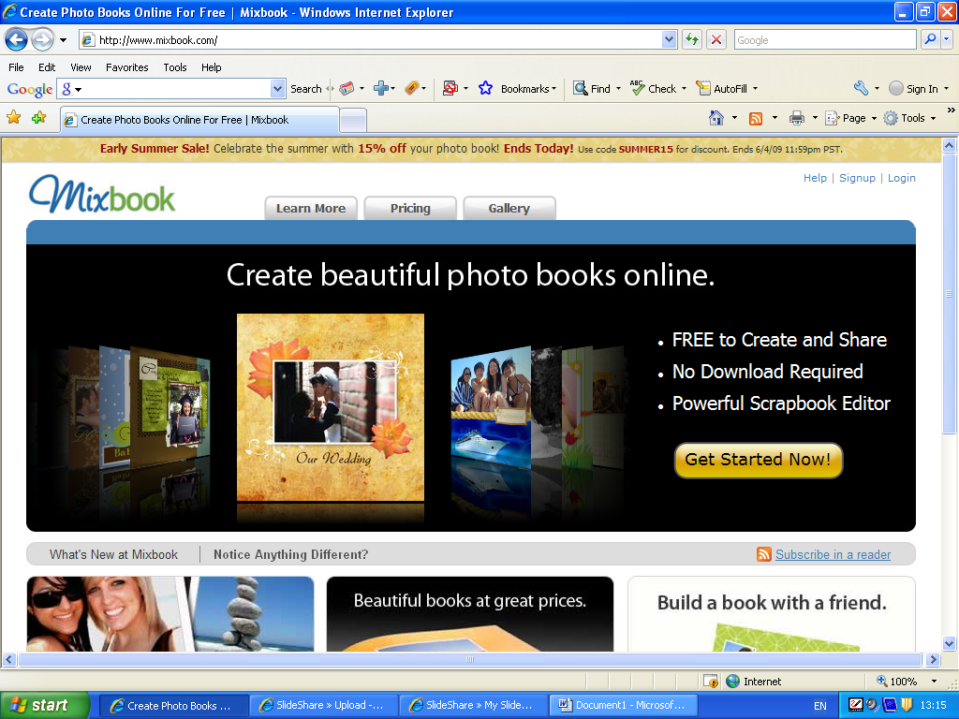
- Click on Signup

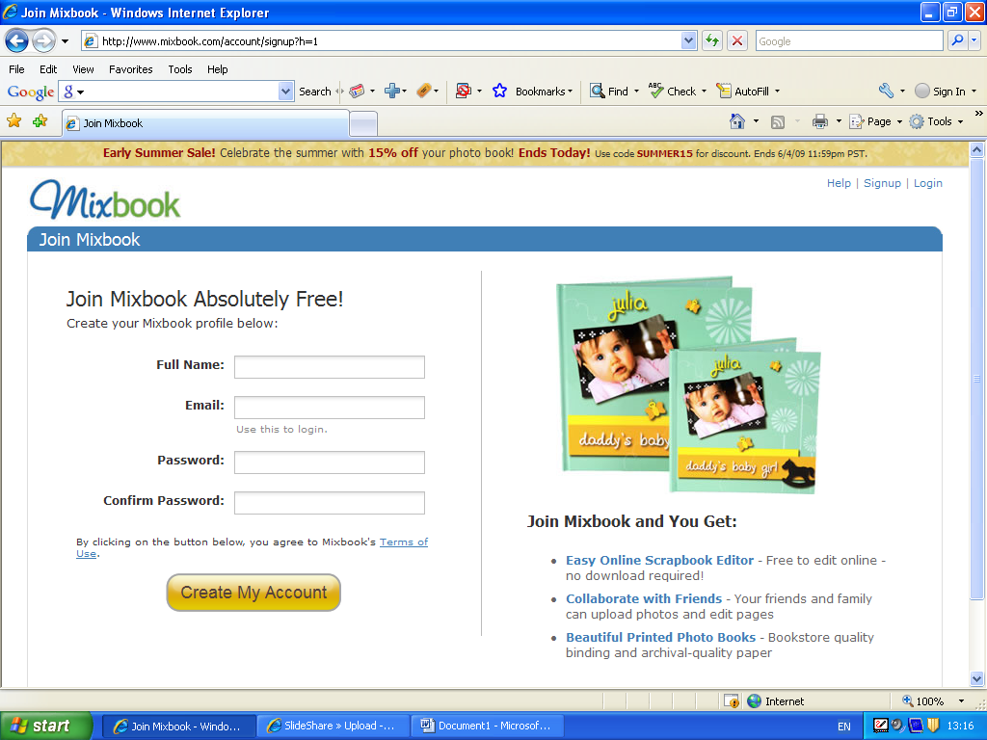
- Fill in the registration details and press create my account. Write down the details of your password in your homework diary as you will not be able to retrieve your work if you do not have your password.

- It will ask you to invite your friends to join – Click on Skip this step

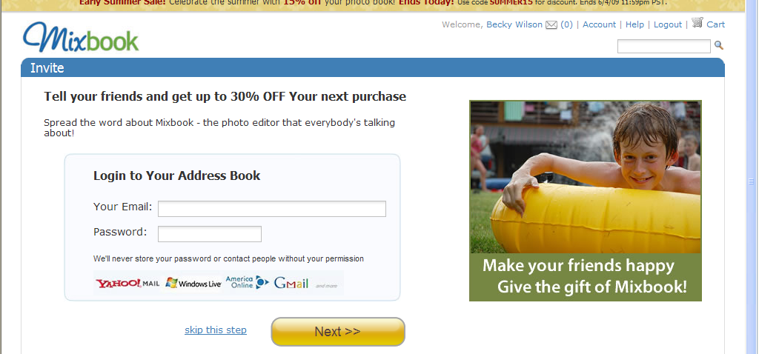

5. This is your home page. Click on Create to start your book.

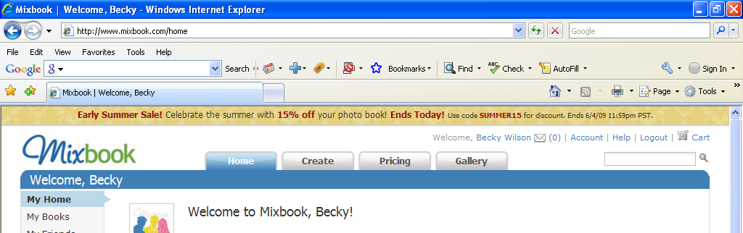

- Fill in the title and choose the Category Education.
- Where it asks who can see it, click only those invited.
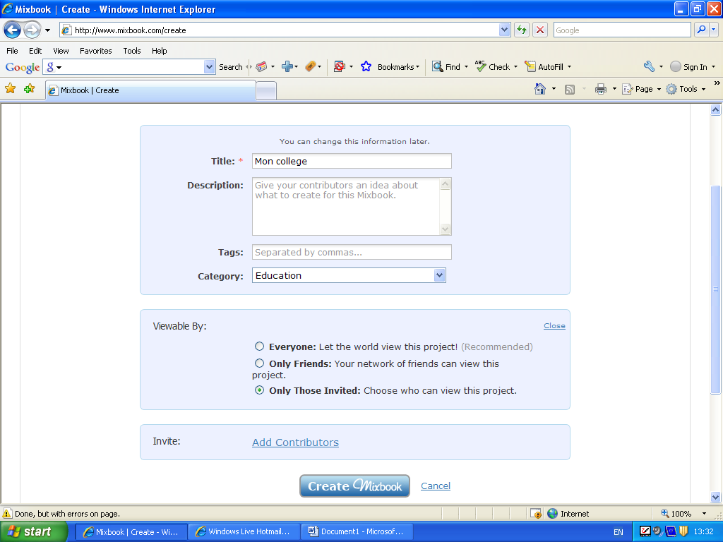

7.Click on Add Contributors.
8. Type my email address in the box and click on Create mixbook. This allows me to be able to access your work and correct it for you.
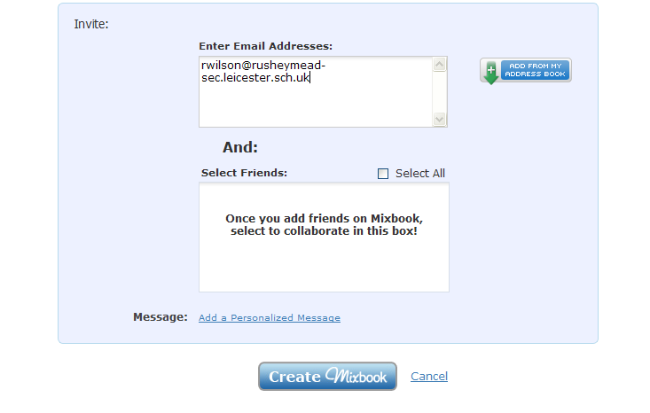

- Next, you need to choose a theme for your book.
Choose the blank canvas theme for your mixbook.
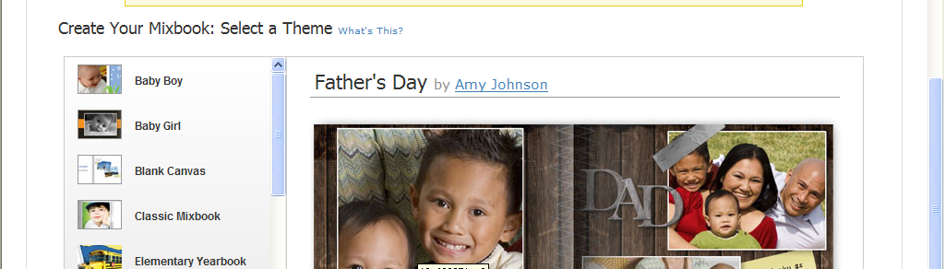

10.Click on choose theme. You may need to do this on the next page also.

11. Take a guided tour of the site or Click on the X to remove it

12.Delete the next box temporarily.

13.Click on Backgrounds and select a background for your book from the choice available. ( later on, you can upload your own picture if you want and replace this)

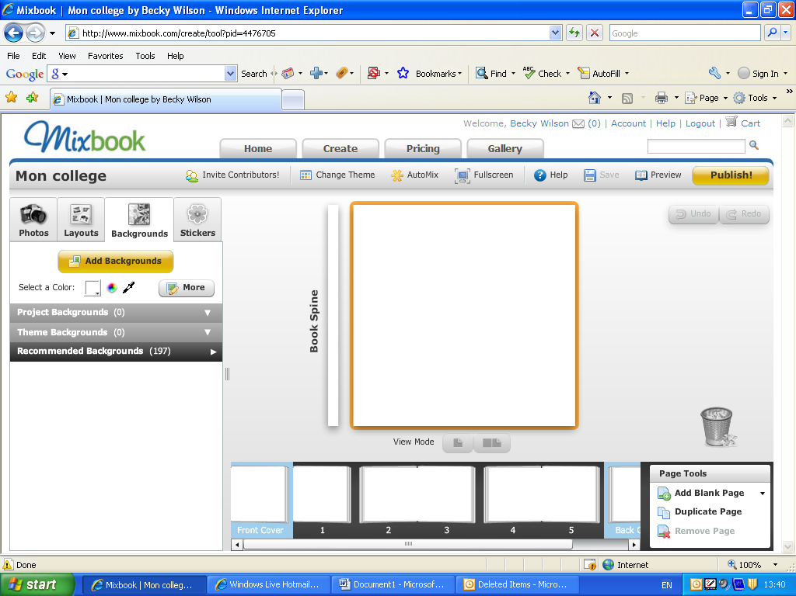

14. To add text click on Layout and add text item
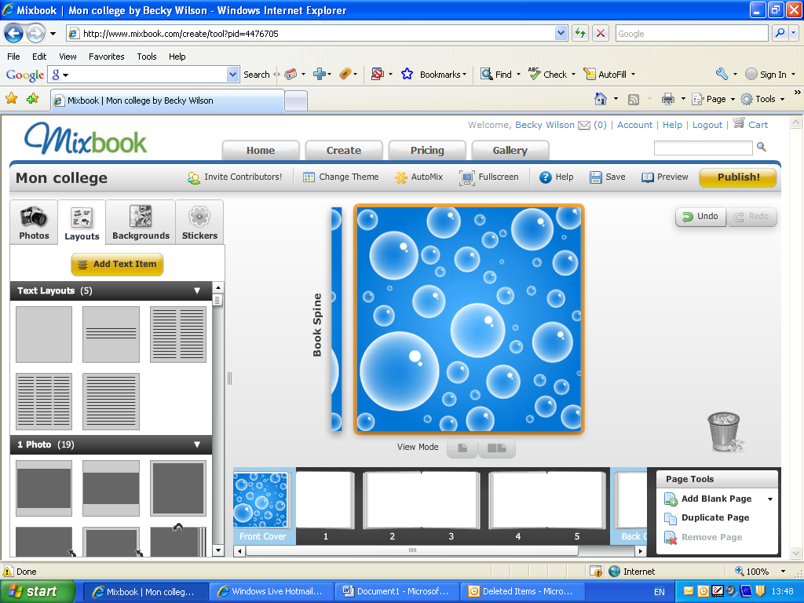

Click on the text box to add your text. DO NOT WORRY ABOUT ACCENTS AS THE MIXBOOK DOES NOT RECOGNISE THEM.
You can rotate the text as you wish and experiment with different styles and effects. Make sure your font is a reasonable size as it will need to clear for others to read when it is on blog.

15. Repeat this for each page of your book. Scroll along the pages at the bottom to change from page to page.

16. When you have finished, you need to add pictures. Before you add them to your mixbook, you need to save them in to your area.
You can upload some photos from home or you can go on the Internet and save some pictures to your school account.

17. When you have saved your photos, you can start uploading them to mixbook.

18. Click on Photos, then Add Photos
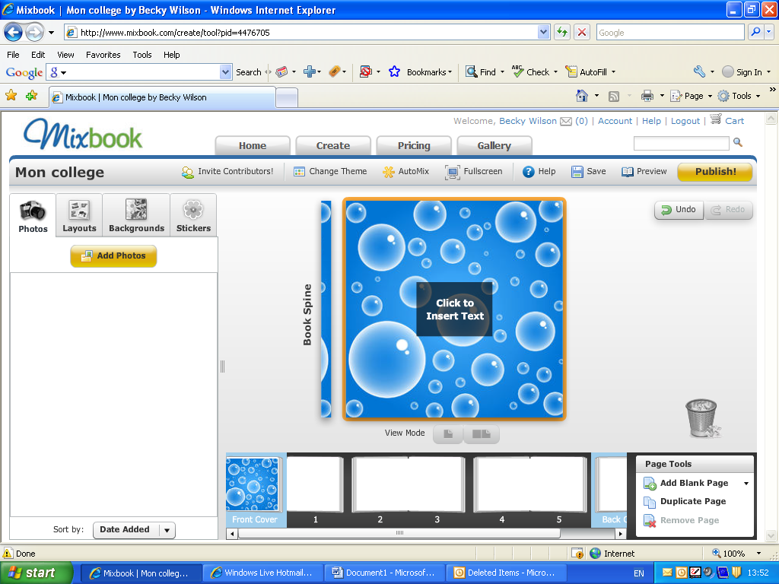

19. Go to the folder where you have saved your photos, select the ones you want and upload them to Mixbook
Your photos will appear in the left hand side box
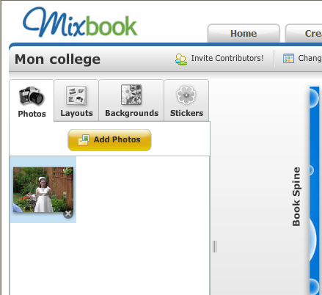
Drag them over to the page you want the photo to be.

When you have finished illustrating your book, click on Save.

When I have checked it, I will publish it to the blog.

Have fun.

